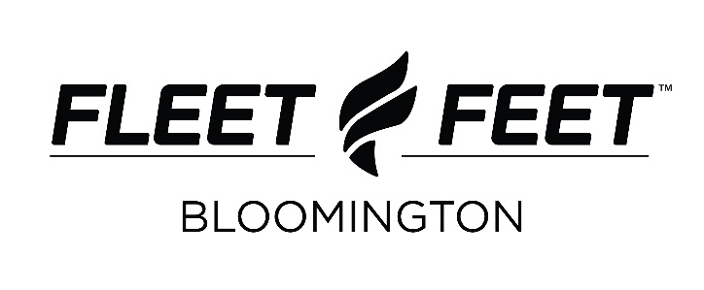
Donation Request Form

Thank you for your donation request from Fleet Feet Bloomington. Type all information below and drop your form off at the store. Please understand that we receive numerous sponsorship requests each week and may not be able to accommodate your entire request. Due to our own charitable initiatives we are unable to fulfill requests for a monetary donation. Forms must be submitted at least 30 days prior to the event. After turning in your form, we encourage you to follow-up to check on the status of your request.

Charity / Organization Name

Event Name

Event Date

Contact Name

Phone Number

Email Address

Donation Type and Estimated Quantity

Race Bibs
Race Bags
Store Gift Certificates
Training Program Gift Certificates
Store Coupons for Race Bags
Raffles/Giveaways
Host in-store packet pick-up
List event on website
Advertise event in store
Borrow race supplies:
Mile marker signs (6)
Five gallon coolers (2)
Ten gallon coolers (4)
Large orange cones (4)
Tubs (2)
Stopwatches for mile splits (3)
Chairs (40 for indoor use only)
Tables
Tent (10x10)

Other (please be specific)

Have you shopped with Fleet Feet? How was your experience?

Has Fleet Feet donated to your cause/organization before? If so, what was donated and when?

Provide a short description of your event.

Describe what your ideal donation would be and why.

How will Fleet Feet be recognized for this donation?

